# Experiment No.: 4 Date: 07-03-2023

**AIM**: Familiarization of linux commands.

**CO2**: Perform system administration task.

**Procedure:**

1. Cut command - to cut char

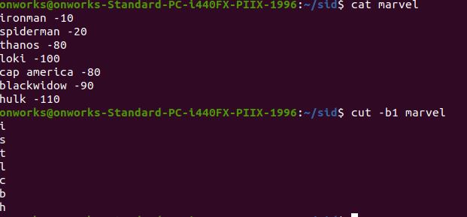

* 1. cut - c :cut letters from a file

$cut -c 1,2,4, marvel

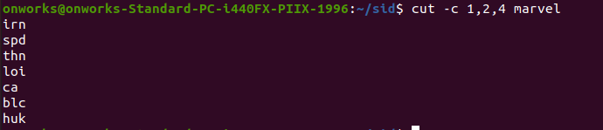

1. paste contents of one file to other

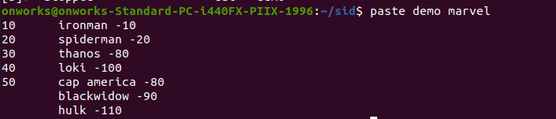

* 1. paste contents of two files into a third file

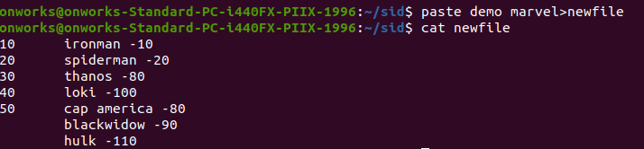

* 1. append using paste command

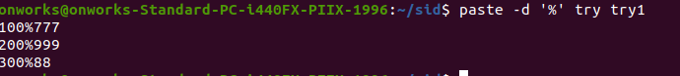

# Result

The program was executed and the result was successfully obtained. Thus CO2 was obtained